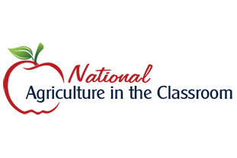 Ellis County Farm Bureau Association

National Agriculture in the Classroom Conference

Minneapolis, MN June 23-26, 2025

Ellis County Farm Bureau is offering a $1000.00 reimbursement to a local educator to attend the National Ag in the Classroom Conference.

The teacher will be reimbursed with proof of attendance.

Did you apply for a NACC scholarship through agclassroom.org ?

Name________________________________________

Phone________________________________________

Email________________________________________

School & Grade________________________________

Principal______________________________________

Do you implement any Agriculture into your curriculum? If so, please explain how you are currently doing this.

Why is it important to implement Agriculture into your curriculum?

How do you plan to use your new knowledge after the conference?